# WEEK 4- ASSIGNMENT

Diametrical Magnetization:

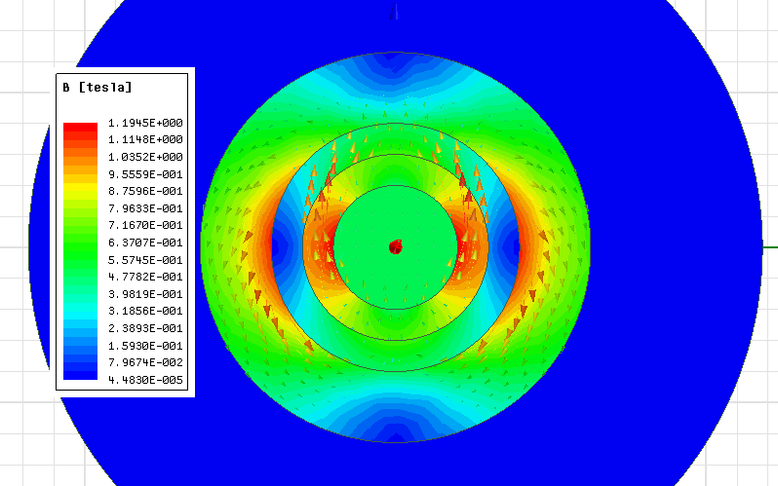

Figure 1-Flux density magnitude and vector

Stator and Rotor are iron.

Magnet is NdFe30.

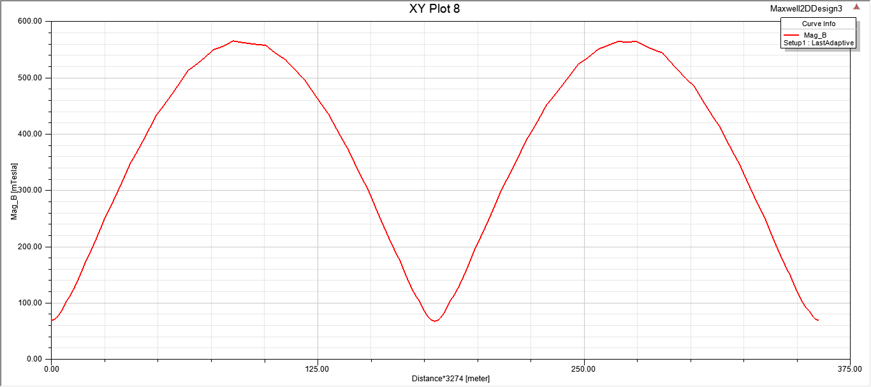

Figure 2-Angle vs B_mag

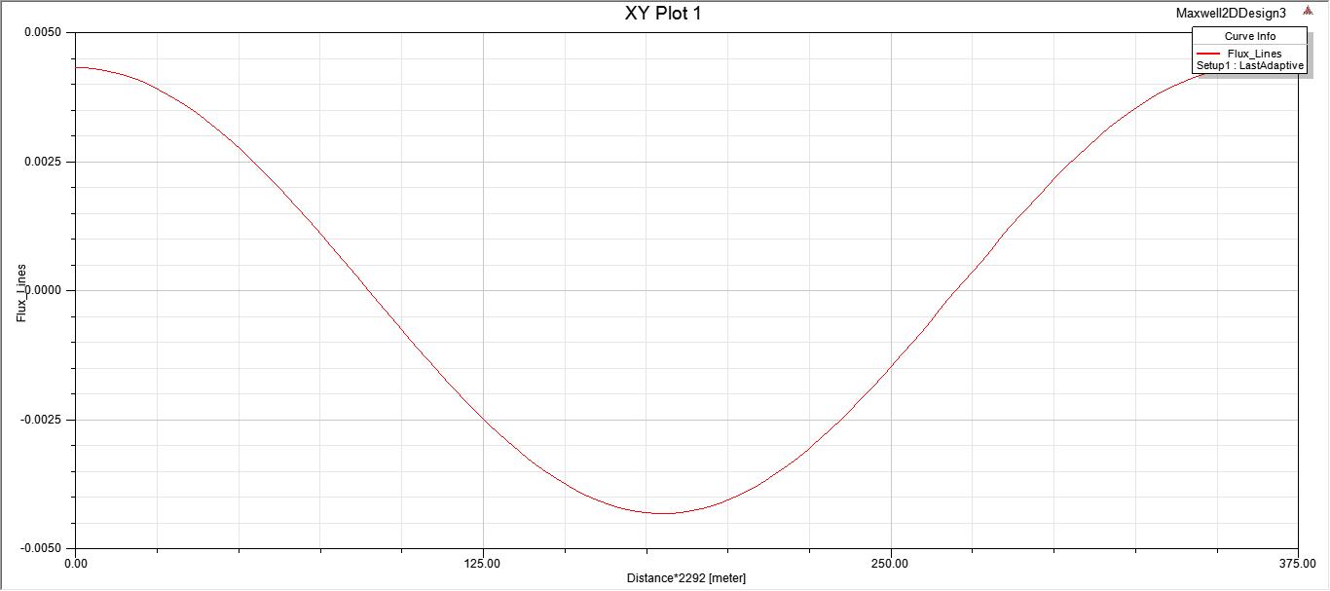

Figure 3 -Angle vs Flux linkage

Radial PM

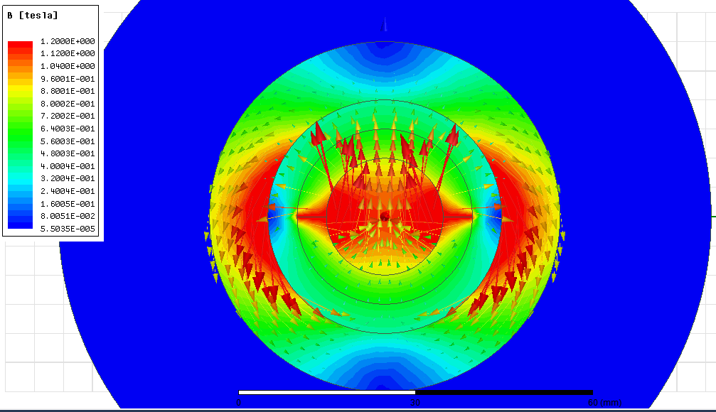

Figure 4- Flux density magnitude and vector

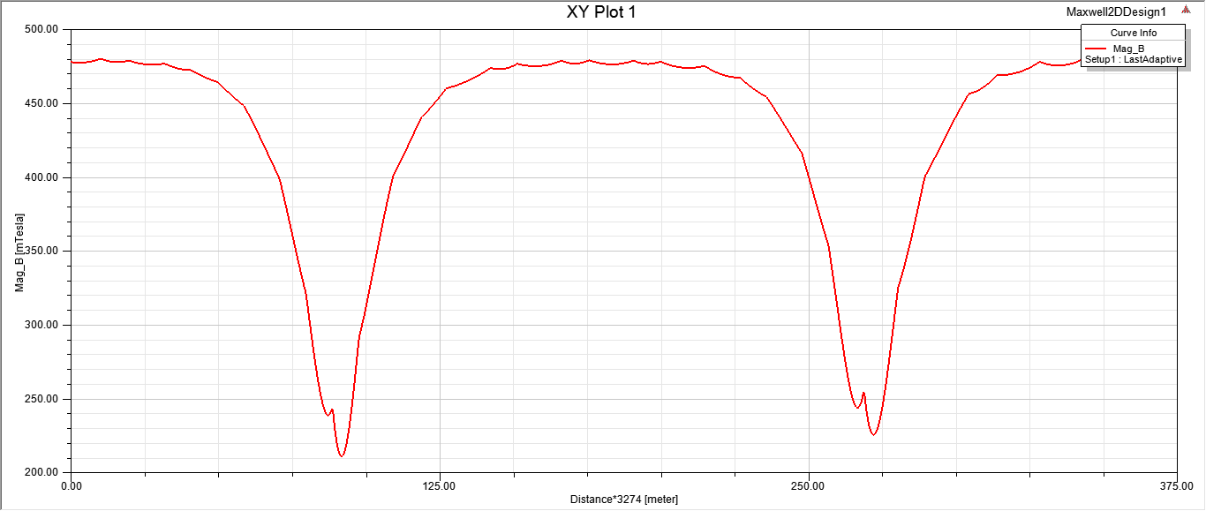

Figure 5- Angle vs B_mag

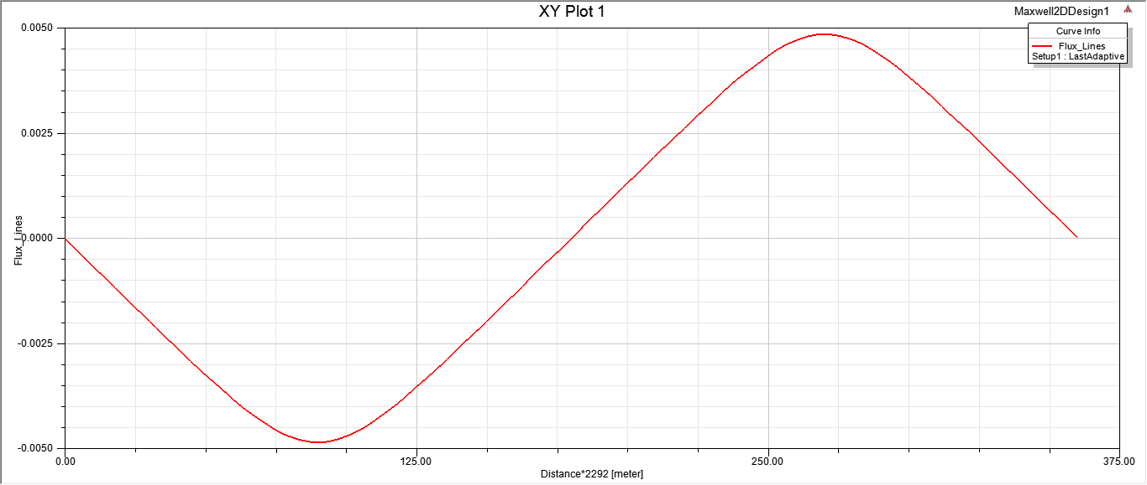

Figure 6-Angle vs Flux lines